Hypothesis Testing Exercise A F&B manager wants to determine whether there is any significant difference in the diameter of the cutlet between two units. A randomly selected sample of cutlets was collected from both units and measured? Analyze the data and draw inferences at 5% significance level. Please state the assumptions and tests that you carried out to check validity of the assumptions. File : Cutlets.csv

Solution

shapiro.test(unitA) # p= 0.32 high null fly - Data is normal

shapiro.test(unitB) # p=0.5225 high null fly - Data is normal

var.test(unitA,unitB) # p = 0.3136 P high null fly - Variances are equal

t.test(unitA , unitB , alternative = "two.sided" , conf.level = 0.95) # p = 0.4723 P high null fly - diameters are equal

Inference – There is no significant differences in the diameter

Hypothesis Testing Exercise A hospital wants to determine whether there is any difference in the average Turn Around Time (TAT) of reports of the laboratories on their preferred list. They collected a random sample and recorded TAT for reports of 4 laboratories. TAT is defined as sample collected to report dispatch. Analyze the data and determine whether there is any difference in average TAT among the different laboratories at 5% significance level.

File: LabTAT.csv

shapiro.test(one) # p= 0.55 high null fly - Data is normal

shapiro.test(two) # p= 0.86 high null fly - Data is normal

shapiro.test(three) # p= 0.42 high null fly - Data is normal

shapiro.test(four) # p= 0.66 high null fly - Data is normal

var.test(one,two) # p = 0.1675 P high null fly - Variances are equal

var.test(three,two) # p = 0.2742 P high null fly - Variances are equal

var.test(four,three) # p = 0.3168 P high null fly - Variances are equal

anova_results <- aov(values ~ ind , data = stacked_data)

summary(anova_results) # p = 2e-16 P low null go – At least one TAT is unequal

Inference – At least one of the TAT is unequal

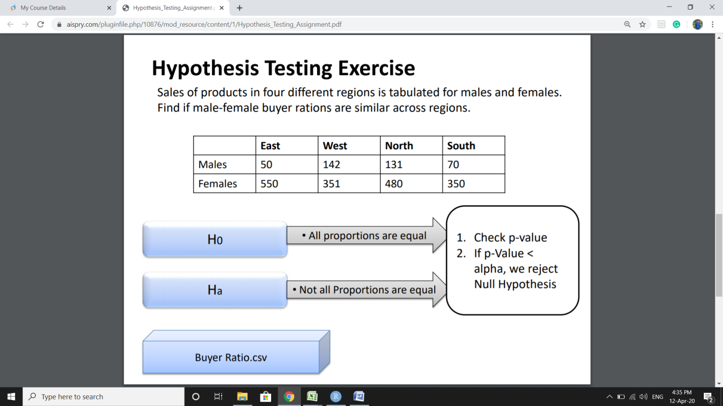

chisq.test(table(observed,Direction)) # p = 0.6603 P high null fly – proportions are equal

Inference: All regions have equal proportions

TeleCall uses 4 centers around the globe to process customer order forms. They audit a certain % of the customer order forms. Any error in order form renders it defective and has to be reworked before processing. The manager wants to check whether the defective % varies by centre. Please analyze the data at 5% significance level and help the manager draw appropriate inferences

File: CustomerOrderForm.csv

chisq.test(table(stacked_data)) # p = 0.2771 P high null fly - Errors are equal across centers

Inference: The defective % does not vary by center.

Fantaloons Sales managers commented that % of males versus females walking in to the store differ based on day of the week. Analyze the data and determine whether there is evidence at 5 % significance level to support this hypothesis. File: Fantaloons.csv

chisq.test(table(stacked_data)) # p = 8.53e-05 P low null go - There is a significance differnce in % of male & female walk in to the store depending on the days